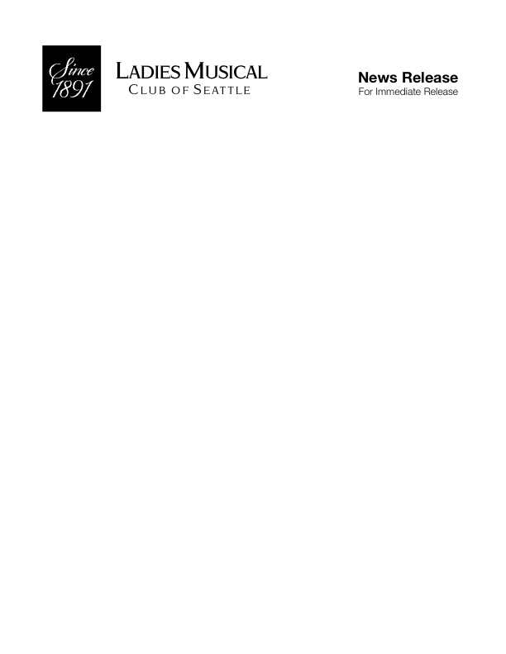

LMC Adds 10 More Performances to its 2017–2018 Season of
Free Public Concerts Throughout Metro-Seattle

Sixty free performances at SAM, Seattle Public Libraries/Central & West Seattle, Frye Art Museum, Music Center of the Northwest,
Bellevue Crossroads Community Center, Mirabella,
University House/Wallingford, NEW this season – SeaTac Community Center and St. John’s Episcopal/Kirkland

Ladies Musical Club is one of the top 14 best free events in Seattle.
—Lonely Planet, 2015

Seattle, WA – September 13, 2017 -The Ladies Musical Club of Seattle (LMC), with an educational mission to foster classical music in its community, is adding 10 more FREE public concerts during its new 2017-2018 Season starting September 30. The member-musicians and their guest artists will present 60 concerts at Seattle Art Museum, Frye Art Museum, Seattle Central Public Library, West Seattle Library, Mirabella, Music Center of the Northwest, University House/Wallingford, Crossroads Community Center Theater in Bellevue, and New venues this season - SeaTac Community Center and St. John’s Episcopal Church/Kirkland (see venue addresses, September-December programs below). All performances are FREE to the public and most are one-hour in length. Concerts at the Music Center of the Northwest are 90-minutes and include post-concert refreshments. NOTE: The first SeaTac Community Center series performance has been moved from October 1 to Saturday, September 30 at 1:00 p.m.

2017–2018 LMC Season Program Highlights

Tribute to the Life and Works of Debussy
Mahler’s Kindertotenlieder
Ravel’s Histoires naturelles
Schumann’s Frauenliebe und -leben
Barber’s Hermit Songs and
Knoxville, Summer of 1915
Copland’s Appalachian Spring
Italian opera from Verdi to Verismo
Russian Opera of the 19th Century
Baroque Opera
20th Century Opera
String music by Mozart, Kodaly, Brahms, Ravel,
Beethoven and Grieg
All-Bach Concert, celebrating the birth month of
Johann Sebastian Bach
Spanish music for voice and guitar, solo piano

A full season of activities can be found on the LMC website at www.lmcseattle.org as LMC members also will host classical and world music artists in underserved Seattle Public Schools through its Music in Schools program that collaborates with Meany Hall for the Performing Arts. The 2018 Frances Walton Competition will be held next June at Magnolia Lutheran Church, featuring 20-35 year old classical artists who live, work or study in 19 Western states, performing in piano, voice, strings and instruments. Each fall, competition winners travel the state bringing classical music to outlying Washington communities and schools.

For more information about Ladies Musical Club of Seattle, public concert performance schedule and donation options, visit www.lmcseattle.org. Find Ladies Musical Club of Seattle on Facebook, Twitter and Instagram.

About Ladies Musical Club of Seattle
Ladies Musical Club of Seattle was founded in 1891 by a group of 24 women musicians. Its original mission was to foster an appreciation of classical music in the cultural life of a city that was just starting to find its identity. For more than a century, the LMC members presented a stellar International Artist Series whose make up is literally a Who’s Who list of classical music artist luminaries such as: Sergei Rachmaninoff, Fritz Kreisler, Jascha Heifetz, Marian Anderson, Kirsten Flagstad, Artur Rubinstein, Vladimir Horowitz, Marilyn Horne, Alicia de Larrocha, Nadja Salerno-Sonnenberg, Joshua Bell, and the Chicago Symphony Orchestra, the New York Symphony Orchestra, and the London Chamber Orchestra as well. See the entire list. Although no longer presenting international artists, LMC continues to foster classical music in the community through education, performance and awards. MOHAI houses LMC’s historical archives.
–All programs, artists and dates subject to change–
Support for the 2017–2018 Season is provided by 4Culture and Seattle Office of Arts & Culture

2017–2018 Season Media Sponsor is Classical KING FM 98.1

###

Media Contact (do not publish) Media requests for photos, interviews and other press items relating to Ladies Musical Club and performing artists are welcome.
Mary G. Langholz, LMC communications consultant:
vote4arts (at) outlook.com (unavailable 10/6-10/23)

Release #1718-3
September 13, 2017

LMC PUBLIC CONCERT VENUES AND ADDRESSES
Crossroads Community Center/Theater, 16000 N. E. 10th Street, Bellevue
Frye Art Museum/Frye Auditorium, 704 Terry Avenue, Seattle
Mirabella/Emerald Hall, 116 Fairview Avenue North, Seattle
Music Center of the Northwest, 901 North 96th Street, Seattle
SeaTac Community Center, 13735 24th Ave South, SeaTac
Seattle Art Museum/Plestcheeff Auditorium, 1300 1st Avenue, Seattle
Seattle Public Library/Central/Microsoft Auditorium, 1000 4th Avenue, Seattle
Seattle Public Library/West Seattle, 2306 42nd Avenue SW, Seattle
St. John’s Episcopal Church, 105 State Street South, Kirkland
University House/Wallingford, 4400 Stone Way North, Seattle

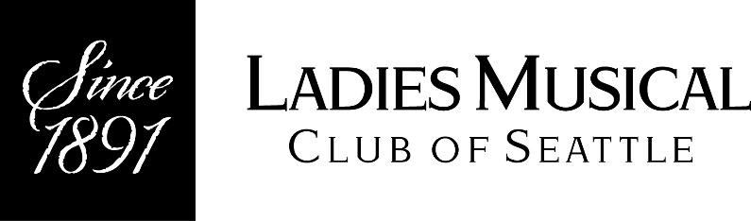

2017 FALL FREE PUBLIC CONCERT SERIES
Venues, September – December Dates and Times
All concerts are FREE and most are approximately one hour long.
Current program details are available at www.lmcseattle.org (Public Concert Series)

SeaTac Community Center
13735 24th Ave S, SeaTac
Co-sponsored by the City of SeaTac
Approximate length: 90 minutes
September 30 at 1 p.m.
Famous French Melodies for Solo Piano and Voice
Tiina Ritalahti, Katie Hochman, Ya-Li Lee and Regina Thomas, sopranos
Karin McCullough, Joan Lundquist and Lucy Wenger, piano
Seattle Art Museum
1300 First Ave, Seattle
October 5 at 12 p.m.
Brahms Songs and Duets and Mahler’s Kindertotenlieder
Regina Thomas, soprano, Gwen Trussler, mezzo soprano,
Rosemary Bell, oboe, Laurie Heidt, French Horn (guest artist)
Shirley Wu and Johanna Mastenbrook, piano

November 2 at 12 p.m.
Art of Piano: Darkness and Light
Karin McCullough, piano
Valentina Rodov, piano
Geisa Dutra, piano

December 7 at 12 p.m.
For Snow Song Cycle by Janet Anderson and Ensemble Works Featuring Recorder
Katie Hochman, soprano and Janet Anderson, piano
Jill Carlsen, Sabine Endrigkeit, Vicki Boekman (guest artist) and Mike Woolf (guest artist), recorders

Frye Art Museum
704 Terry Ave, Seattle
October 7 at 2 p.m.
Solo Recitals for Oboe and Piano
Sharon Jung, oboe, Lucy Wenger, piano and Joyce Gibb, piano

November 4 at 2 p.m.
The Life and Works of Claude Debussy
Ya-Li Lee, Clarice Warrick and Jill Carlsen, sopranos
Janene Nelson and Kathryn Vinson, mezzo sopranos
Lucy Wenger and Karin McCullough, piano
Candice Chin, violin
Terry Cook, cello

December 2 at 2 p.m.
Classical Guitar Recital and Histoires Naturelles by Ravel
Hilary Field, guitar
Dawn Padula, mezzo soprano

Seattle Public Library/ West Seattle Branch
2306 42nd Ave SW, Seattle
October 8 at 3 p.m.
LMC Opera Presents “The Italians: Verdi to Verismo”
Katie Hochman, Diane Althaus and Regina Thomas, sopranos
Gwen Trussler, mezzo soprano
Jennifer Li, piano

November 12 at 3 p.m.
Soprano Recital and Mozart String Quartet No. 23 in F major, K.590
Mele Santos, soprano and Joan Lundquist, piano
Kathryn Zufall and Sally Hufbauer, violin
Barb Clagett, viola
Fran Walton, cello

December 10 at 3 p.m.
Schumann’s Frauenliebe und -Leben (Woman’s love and life)
Lin Chen, soprano and Nicole Truesdell, piano

Seattle Public Library/Central Branch
1000 Fourth Ave, Seattle
October 11 at 12 p.m.
Mozart String Quartet No. 23 in F major, K.590, and Solo Piano Recital
Kathryn Zufall and Sally Hufbauer, violin
Barb Clagett, viola
Fran Walton, cello
Geisa Dutra, piano

November 8 at 12 p.m.
Operetta and Musical Theater Music for Soprano
Christine Menschner, soprano and Joan Lundquist, piano

December 13 at 12 p.m.
Recitals for Solo Voice and Piano
Amber Rose Johnson, soprano
Valentina Rodov, piano
Mirabella
116 Fairview Ave N, Seattle
October 15 at 3 p.m.
LMC Opera Presents “The Italians: Verdi to Verismo”
Katie Hochman, Diane Althaus and Regina Thomas, sopranos
Gwen Trussler, mezzo soprano
Jennifer Li, piano

November 19 at 3 p.m.
Mozart String Quartet No. 23 in F major, K.590 and “French Romantic Songs and Duets”
Kathryn Zufall and Sally Hufbauer, violin
Barb Clagett, viola
Fran Walton, cello
Katie Hochman, soprano and Catherine Treadgold, mezzo soprano
Joan Lundquist, piano

December 17 at 3 p.m.
Recital for Oboe
Sharon Jung, oboe

Music Center of the Northwest
901 North 96th St, Seattle
Approximately 90 minutes
October 28 at 7 p.m.
The Life and Works of Claude Debussy
Ya-Li Lee, Clarice Warrick and Jill Carlsen, sopranos
Janene Nelson and Kathryn Vinson, mezzo sopranos
Eun Hee Cho, conductor
Candice Chin, Ann Rackl and Kathy Zufall, violins
Janice Gockel, viola
Terry Cook, cello
Madeline Beery, flute
Lucy Wenger and Karin McCullough, piano

December 3 at 3 p.m.
Original Works by LMC Composers: “Expressions of Winter”
Original works for voice and piano by LMC-member composers
Crossroads Community Center
16000 NE Tenth Street, Bellevue
November 9 at 1 p.m.
LMC Opera Presents “Russian Scenes and Arias”
Music by Glinka, Mussorgsky, Tchaikovsky, Rimsky-Korsakov and Borodin
Regina Thomas and Meg Daly, sopranos
Dawn Padula and Janene Nelson, mezzo sopranos
Maria Khavin, piano

University House, Wallingford
4400 Stone Way North, Seattle.
November 13 at 7:30 p.m.
LMC Opera Presents “Russian Scenes and Arias”
Music by Glinka, Mussorgsky, Tchaikovsky, Rimsky-Korsakov and Borodin
Regina Thomas and Meg Daly, sopranos
Dawn Padula and Janene Nelson, mezzo sopranos
Maria Khavin, piano

December 11 at 7:30 p.m.
Music for Solo Oboe and Flute/Oboe Ensemble
Madeline Beery, flute
Sharon Jung, oboe
Rosemary Bell, oboe/English horn

